

**EASTERN GOLDFIELDS COLLEGE**

**SEMESTER 1 EXAM 2018**

**Question/Answer Booklet**

**ATAR Integrated Science**

**UNIT 1**

**NAME: _________________________________**

**TEACHER: ______________________________**

**Time allowed for this exam**

Reading time before commencing work: ten minutes

Working time for paper: two and a half hours

**Materials required/recommended for this exam**

***To be provided by the supervisor***

This Question/Answer booklet

Multiple-choice answer sheet

***To be provided by the candidate***

Standard items: Pens (blue/black preferred), pencils (including coloured), sharpener, correction fluid/tape, eraser, ruler, highlighter.

Special items: Non-programmable calculators approved for use in this examination

**Important note to candidates**

No other items may be taken into the examination room. It is **your** responsibility to ensure that you do not have any unauthorised material. If you have any unauthorised material with you, hand it to the supervisor **before** reading any further.

***Structure of this paper***

|  |  |  |  |  |  |
| --- | --- | --- | --- | --- | --- |
| Section | Number of questions available | Number of questions to be answered | Suggested working time (minutes) | Marks available | Percentage of Exam |
| Section One:  Multiple choice | 30 | 30 | 25 | 20 | 20 |
| Section Two:  Short answers | 6 | 6 | 75 | 75 | 50 |
| Section Three:  Extended answers  Unit 1  Unit 1 | 1 | 1 | 50 | 45 | 30 |
| 1 | 1 |
|  |  |  | | Total | 100 |

***Instructions to candidates***

1. The rules for the conduct of Western Australian external examinations are detailed in the *Year 12 Information Handbook 2017.* Sitting this examination implies that you agree to abide by these rules.

2. Answer the questions according to the following instructions.

Section One: Answer **all** questions on the separate Multiple-choice answer sheet provided. For each question shade the box to indicate your answer. Use only a blue or black pen to shade the boxes. If you make a mistake, place a cross through that square and then shade your new answer. Do not erase of use correction fluid/tape. Marks will not be deducted for incorrect answers. No marks will be given if more than one answer is completed for any question.

Section Two: Write your answers in the spaces provided in this Question/Answer Booklet. Wherever possible, confine your answers to the line spaces provided.

Section Three: Consists of two parts each with two questions. You must answer one question from each part. Tick the box next to the question you are answering. Write your answers in the question booklet provided

3. You must be careful to confine your responses to the specific questions asked and to follow any instructions that are specific to a particular question.

4. Supplementary pages for the use of planning/continuing your answer to a question have been provided at the end of this Question/Answer booklet. If you use these pages to continue your answer, indicate at the original answer where the answer is continued, i.e. give the page number.

**Section One: Multiple-choice 30% (20 Marks)**

This section has **20** questions. Answer **all** questions on the separate Multiple-choice answer sheet provided. For each question, shade a box to indicate your answer. Use only a blue or black pen to shade the boxes. If you make a mistake, place a cross through that square, then shade your new answer. Do not erase or use correction fluid/tape. Marks will not be deducted for incorrect answers. No marks will be given if more than one answer is completed for any question.

Suggested working time: 25 minutes.

_______________________________________________________________________________________________

1. The nervous system can be divided into two parts, they are the:
   1. Sympathetic and Parasympathetic.
   2. Central and Somatic.
   3. Autonomic and Somatic.
   4. Central and Peripheral.
2. The signal of a reflex arc can best be described as:
   1. Stimulus > sensory neuron > spinal cord > motor neuron > effector
   2. Stimulus > motor neuron > spinal cord > sensory neuron > effector
   3. Effector > sensory neuron > spinal cord > motor neuron > stimulus
   4. Effector > sensory neuron > spinal cord > motor neuron > effector
3. Which of the following statements is not true for someone driving under the influence of cannabis:
   1. Reaction time is increased.
   2. Being under the influence increases concentration.
   3. Driver perception is reduced.
   4. Coordination is reduced.
4. The human hearing range is?
   1. 10-10 000 Hz
   2. 10-20 000Hz
   3. 20-10 000Hz
   4. 20-20 000Hz
5. In WA the legal blood alcohol percentage for a probationary driver is:
   1. 0.00
   2. 0.05
   3. 0.08
   4. 0.15
6. Many injuries are caused in vehicle accidents due to the passenger colliding with the dashboard. One reason a padded dashboard will reduce injuries in a collision compared to a hard dash is that the padded dash:
   1. reduces the force
   2. reduces the impulse
   3. reduces the momentum
   4. reduces the time of impact
7. Research indicates that young drivers face a significantly higher risk of being seriously injured than other drivers. The most likely contributing factor to this greater risk is:
   1. drinking and driving.
   2. not wearing a seat belt.
   3. driving more powerful cars.
   4. less developed driving skills, resulting from having little on-road experience.
8. Random roadside drug testing involves a
   1. breath test.
   2. saliva test.
   3. urine test.
   4. blood test.
9. The property of a sound wave that is closely related to its pitch is:
10. loudness.
11. speed.
12. frequency.
13. amplitude.
14. Which of the following are true?
    1. Sound waves have different speeds in vacuum for different frequencies.
    2. Sound waves are transverse waves.
    3. Sound waves require a medium for propagation.
    4. Longer wavelength sounds are lower than shorter wavelength sounds.
15. The function of the cochlea is to:
16. funnel sound waves into the ear.
17. transmit vibrations through the ear.
18. convert vibrations into electrical impulses.
19. release the pressure in the ear.

Refer to the diagram below for question 12

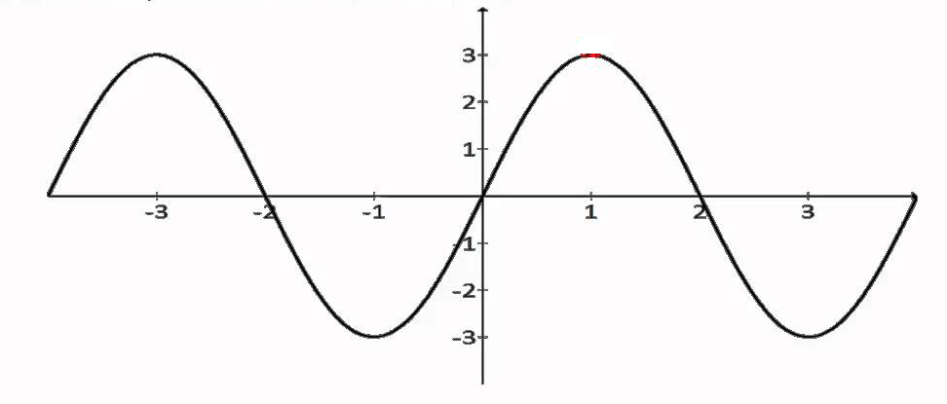

1. The amplitude of the wave is:
   1. 4
   2. 3
   3. 2
   4. 1
2. The distance between two towns is 120km. If Jane can drive this distance in 1.5 hours, Jane’s average speed for the journey would be:
3. 80 km.hr-1
4. 100 km.hr-1
5. 110 km.hr-1
6. 125 km.hr-1
7. Which of the following statements correctly states Newton's first law of motion?
8. Every object retains its state of rest or its state of accelerated straight-line motion unless acted upon by an unbalanced force.
9. Every object retains its state of rest or its state of uniform straight-line motion unless acted upon by a balanced force.
10. Every object retains its state of rest or its state of uniform straight-line motion unless acted upon by an unbalanced force.
11. None of the above is correct.

15. The acceleration of a car moving at a constant speed of 30 ms –1 is

1. 30 m.
2. 30 ms -1.
3. 15 ms -2.
4. 0.

16. The term inertia means which of the following? The tendency of an object to

1. maintain its mass.
2. remain in motion.
3. remain in rest or motion.
4. stop the motion of other objects.

17. According to Newton's second law of motion, acceleration is directly proportional to force.

That means a larger force:

1. produces a smaller acceleration.
2. doesn't affect acceleration.
3. produces a smaller mass.
4. produces a larger acceleration.

18. You are standing in a moving bus, facing forward, and you suddenly fall forward. You can tell

from this that the bus's

1. velocity decreased.
2. velocity increased.
3. speed remained the same, but it's turning right.
4. speed remained the same, but it's turning left.

The following graph relates to questions 19 and 20

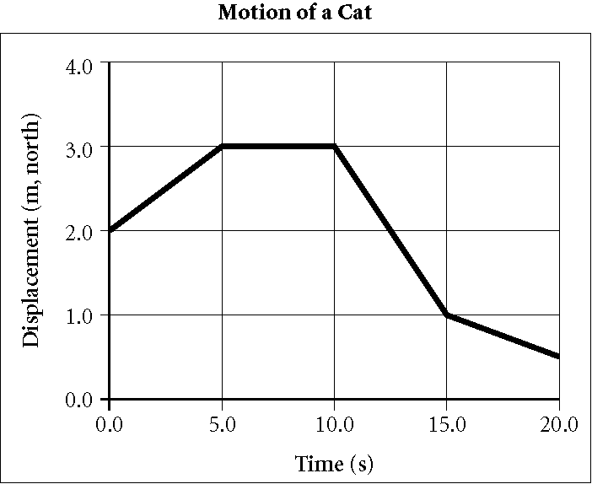

19. According to the graph above, during which interval is the cat at rest?

1. 0.0–5.0 s
2. 5.0–10.0 s
3. 10.0–15.0 s
4. 15.0–20.0 s

20. According to the graph above, the cat has the fastest speed during which interval?

1. 0.0–5.0 s
2. 5.0–10.0 s
3. 10.0–15.0 s
4. 15.0–20.0 s

End of Section One

**This Page is Intentionally Left Blank**

**Section Two: Short response 50%** **(75 Marks)**

This section has five (5) questions. Answer all questions. Write your answers in the spaces provided. Supplementary pages for the use of planning/continuing your answer to a question have been provided at the end of this Question/Answer booklet. If you use these pages to continue an answer, indicate at the original answer where the answer is continued, i.e. give the page number.

Suggested working time: 90 minutes.

_____________________________________________________________________________

**Question 21 (18 Marks)**

The nervous system allows a driver to be aware of his or her surroundings and react to any changes that are occurring.

1. Draw a labelled diagram of a nerve cell. (3 Marks)
2. Name and describe the function of the three types of nerve cells. (3 Marks)

______________________________________________________________________________________________________________________________________________________________________________________________________________________________________________________________________________________________________________________________________________________________________________________________________________________________________________________

1. Explain how a nerve cell transmits a signal from one nerve cell to another (4 Marks)

________________________________________________________________________________________________________________________________________________________________________________________________________________________________________________________________________________________________________________________________________________________________________________________________________________________________________________________________________________________________________________________________________________________________________________________________________

1. Explain why there is a need for a parasympathetic and sympathetic nervous system

(5 Marks)

__________________________________________________________________________________________________________________________________________________________________________________________________________________________________________________________________________________________________________________________________________________________________________________________________________________________________________________________________________________________________________________________________________________________________________________________________________________________________________________________________________________________________________________________________________________________

1. Explain the function of the following parts of the brain (3 Marks)
2. Cerebrum

______________________________________________________________________________________________________________________________________

1. Cerebellum

______________________________________________________________________________________________________________________________________

1. Hypothalamus

______________________________________________________________________________________________________________________________________

**Question 22 (21 Marks)**

The stopping distance is a combination of the reaction distance and the stopping distance.

1. Explain how each of the following will influence the reaction distance of a person (3 Marks)
2. Environmental Distractions

_________________________________________________________________________________________________________________________________________________________________________________________________________

1. Alcohol

_________________________________________________________________________________________________________________________________________________________________________________________________________

1. Age

_________________________________________________________________________________________________________________________________________________________________________________________________________

1. Explain the following factors that influence braking distance in a car. (6 Marks)
2. Road conditions:

____________________________________________________________________________________________________________________________________________________________________________________________________________________________________________________________________________

1. Tyre Conditions:

____________________________________________________________________________________________________________________________________________________________________________________________________________________________________________________________________________

1. Mass of the vehicle:

____________________________________________________________________________________________________________________________________________________________________________________________________________________________________________________________________________

1. Drugs and alcohol have a negative effect on the reaction time of a person and are responsible for many deaths on western Australia roads each year.
2. State two tests that can be done to test for drugs. (2 Marks)

______________________________________________________________________________________________________________________________________

1. Discuss the advantages and disadvantages for the two tests stated above in part (i) and create an argument as to which would be better for police to use in road roadside testing. (7 Marks)

____________________________________________________________________________________________________________________________________________________________________________________________________________________________________________________________________________________________________________________________________________________________________________________________________________________________________________________________________________________________________________________________________________________________________________________________________________________________________________________________________________________________________________________________________________________________________________________________________________________________________

_________________________________________________________________________________________________________________________________________________________________________________________________________

1. Explain why it is dangerous to drive under the influence of the following drugs. (3 Marks)
2. Ecstasy

_________________________________________________________________________________________________________________________________________________________________________________________________________

1. Methylamphetamine

_________________________________________________________________________________________________________________________________________________________________________________________________________

1. Cannabis

_________________________________________________________________________________________________________________________________________________________________________________________________________

**Question 23 (16 Marks)**

1. Distinguish between:
2. distance and displacement (2 Marks)

____________________________________________________________________________________________________________________________________________________________________________________________________________________________________________________________________________

1. Speed and velocity. (2 Marks)

____________________________________________________________________________________________________________________________________________________________________________________________________________________________________________________________________________

Use the diagram below to answer the following questions

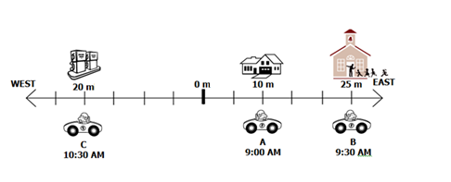

1. Calculate the distance travelled from: (2 Marks)
2. A to C
3. C to B to A
4. Calculate the displacement travelled from: (2 Marks)
5. C to B to A
6. A to C to B
7. Below shows a distance-time graph calculate the speed between intervals:

[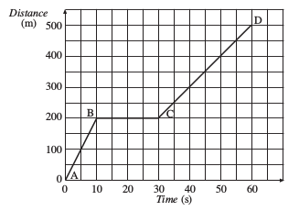](https://www.google.com.au/url?sa=i&source=images&cd=&cad=rja&uact=8&ved=2ahUKEwj8vOT06JvbAhUGzbwKHd-wCoMQjRx6BAgBEAU&url=http://szalonta.hu/ske/text/G2/skeg2s3.html&psig=AOvVaw2GHIMJQ2dbv7yDtKmbTcRc&ust=1527164351124667)

1. C and D (2 Marks)
2. B and C (1 Mark)
3. An aeroplane accelerates from 12.5m/s to 52.1 m/s in 1.47 seconds determine the acceleration of the aeroplane and its displacement. (5 Marks)

**Question 24 (11 Marks)**

A student decided to design an experiment to test the effect of speed on the stopping distance in a car.

1. State the independent variable in this experiment (1 Mark)

_____________________________________________________________________

1. State the dependent variable in this experiment (1 Mark)

_____________________________________________________________________

1. State two variables that need to be controlled and explain why they need to be controlled (2 Marks)

____________________________________________________________________________________________________________________________________________________________________________________________________________________________________________________________________________________

1. State a hypothesis for this investigation. (1 Mark)

__________________________________________________________________________________________________________________________________________

The student conducted the experiment and obtained the results shown in the following table.

|  |  |  |  |
| --- | --- | --- | --- |
| Speed (km h-1) | Reaction distance (m) (m) | Braking distance (m) | Stopping distance (m) |
| 30 | 8 | 5 | 13 |
| 60 | 16 | 20 | 36 |
| 90 | 24 | 45 | 69 |
| 120 | 32 | 80 | 1 12 |

1. Graph the results of the speed and stopping distance in the grid below. (5 Marks)



1. Explain the trends shown in your graph (1 Mark)

___________________________________________________________________________________________________________________________________________________________________________________________________________________________

**Question 25 (9 Marks)**

1. Discuss how the safety features below use Newtons’ Laws to help protect passengers in a vehicle. (4 Marks)
2. Seatbelt

_______________________________________________________________________________________________________________________________________________________________________________________________________________________________________________________________________________________________________________________________________________

1. Electronic Stability control

_______________________________________________________________________________________________________________________________________________________________________________________________________________________________________________________________________________________________________________________________________________

1. Find the force required to accelerate a car of 1,000kg at 5ms2 (2 Marks)
2. Define momentum and state the two factors that influence momentum (3 Marks)

___________________________________________________________________________________________________________________________________________________________________________________________________________________________

End of Section Two

**This Page is Intentionally Left Blank**

**Section Three: Extended Response 30% (45 Marks)**

This section contains two (2) questions. You must answer both questions. Write your answers in the spaces provided. Supplementary pages for the use pf planning/ continuing your answer to a question have been provided at the end of this Question/ Answer booklet. If you use these pages to continue an answer, indicate at the original answer where the answer is continued. i.e. give the page number.

Suggested working time: 50 minutes

______________________________________________________________________________

**Question 27 (25 Marks)**

1. Using examples, explain what determines the speed at which sound travel’s. (4 Marks)

______________________________________________________________________________________________________________________________________________________________________________________________________________________________________________________________________________________________________________________________________________________________________________________________________________________________________________________

1. Explain what determines the following: (4 Marks)
2. Pitch of a sound wave

_________________________________________________________________________________________________________________________________________________________________________________________________________

1. Loudness of a sound wave

_________________________________________________________________________________________________________________________________________________________________________________________________________

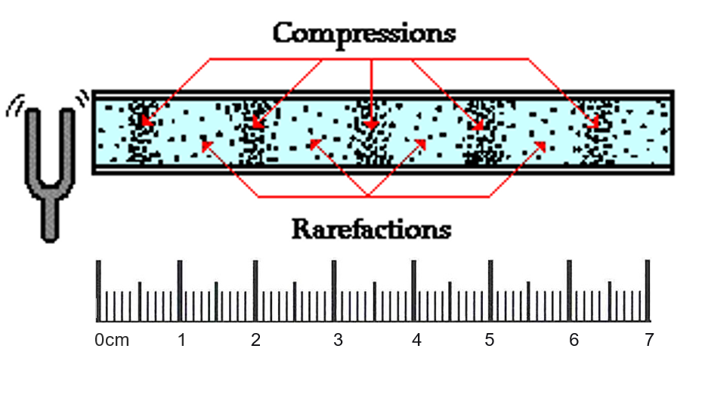The sketch below shows a sound wave use it to answer question (c).

1. Calculate the average wavelength of the sound wave. (2 Marks)
2. The velocity of a sound wave coming in from a source is 20ms-1 and its frequency is 200Hz calculate the wavelength. (2 Marks)
3. Describe the four (4) ways in which sound waves behave (4 Marks)

______________________________________________________________________________________________________________________________________________________________________________________________________________________________________________________________________________________________________________________________________________________________________________________________________________________________________________________

1. Compare constructive interference and destructive interference (4 Marks)

________________________________________________________________________________________________________________________________________________________________________________________________________________________________________________________________________________________________________________________________________________________________________________________________________________________________________________________________________________________________________________________________________________________________________________________________________

1. Explain how an ultra sound uses sound waves to produce an image of the foetus. (2 Marks)

___________________________________________________________________________________________________________________________________________________________________________________________________________________________

1. Use your knowledge of sound to explain the following observations. 'When entering a large, empty gymnasium many echoes are heard. However, when the same gymnasium is full of students, during an assembly, echoes are not so obvious. (3 Marks)

__________________________________________________________________________________________________________________________________________________________________________________________________________________________________________________________________________________________________________________________________________________________________________________________________________________________________________

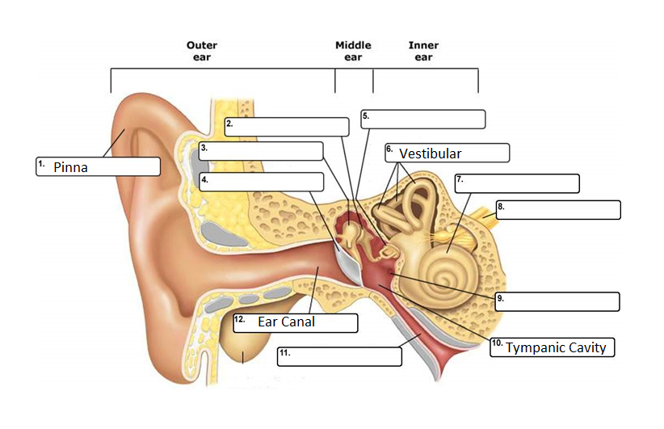**Question 28 (20 Marks)**

1. Label the following diagram of the ear (4 Marks)
2. Explain the movement of a sound through the ear (2 Marks)

________________________________________________________________________________________________________________________________________________________________________________________________________________________________________________________________________________________________________

1. Explain the importance of the function of following parts of the ear that enable us to hear.

(6 Marks)

1. Round window

____________________________________________________________________________________________________________________________________________________________________________________________________________________________________________________________________________________________________________________________________________________________________________________________________________________________________

1. Oval window

____________________________________________________________________________________________________________________________________________________________________________________________________________________________________________________________________________________________________________________________________________________________________________________________________________________________________

1. Distinguish between conductive and sensorineural hearing loss (2 Marks)

________________________________________________________________________________________________________________________________________________________________________________________________________________________________________________________________________________________________________

1. Explain how the following enable a person to hear (2 Marks)
2. Hearing aid:

____________________________________________________________________________________________________________________________________________

1. Cochlea implant:

____________________________________________________________________________________________________________________________________________

1. Using examples explain the importance of updating the technology of hearing aids and

cochlea implants (4 Marks)

______________________________________________________________________________________________________________________________________________________________________________________________________________________________________________________________________________________________________________________________________________________________________________________________________________________________________________________________________________________________________________________________________

End of Section Three

Additional Working Space

_______________________________________________________________________________________________________________________________________________________________________________________________________________________________________________________________________________________________________________________________________________________________________________________________________________________________________________________________________________________________________________________________________________________________________________________________________________________________________________________________________________________________________________________________________________________________________________________________________________________________________________________________________________________________________________________________________________________________________________________________________________________________________________________________________________________________________________________________________________________________________________________________________________________________________________________________________________________________________________________________________________________________________________________________________________________________________________________________________________________________________________________________________________________________________________________________________________________________________________________________________________________________________________________________________________________________________________________________________________________________________________________________________________________________________________________________________________________________________________________________________________________________________________________________________________________________________________________________________________________________________________________________________________________________________________________________________________________________________________________________________________________________________________________________________________________________________________________________________________________________________________________________________________________________________________________________________________________________________________________________________________________________________________________________________________________________________________________________________________________________________________________________________________________________________________________________________________________________________________________________________________________________________________________________________________________________________________________________________________________________________________________________________________________________________________________________________________________________________________________________________________________________________________________________________________________________________________________________________________________________________________________________________________________________________________________________________________________________________________________________________________________________________________________________________________________________________________________________________________________________________________________________________________________________________________________________________________________________________________________________________________________________________________________________________________________________________________________________________________________________________________________________________________________________________________________________________________________________________________________________________________________________________________________________________________________________________________________________________________________________________________________________________________________________________________________________________________________________________________________________________________________________________________________________________________________________________________________________________________________________________________________________________________________________________________________________________________________________________________________________________________________________________________________________________________________________________________________________________________________________________________________________________________________________________________________________________________________________________________________________________________________________________________________________________________________________________________________________________________________________________________________________________________________________________________________________________________________________________________________________________________________________________________________________________________________________________________________________________________________________________________________________________________________________________________________________________________________________________________________

Additional Working Grid **B**

